Chapter 7
The CPU and Memory

7.1 (BL1) See figure 7.1, next page
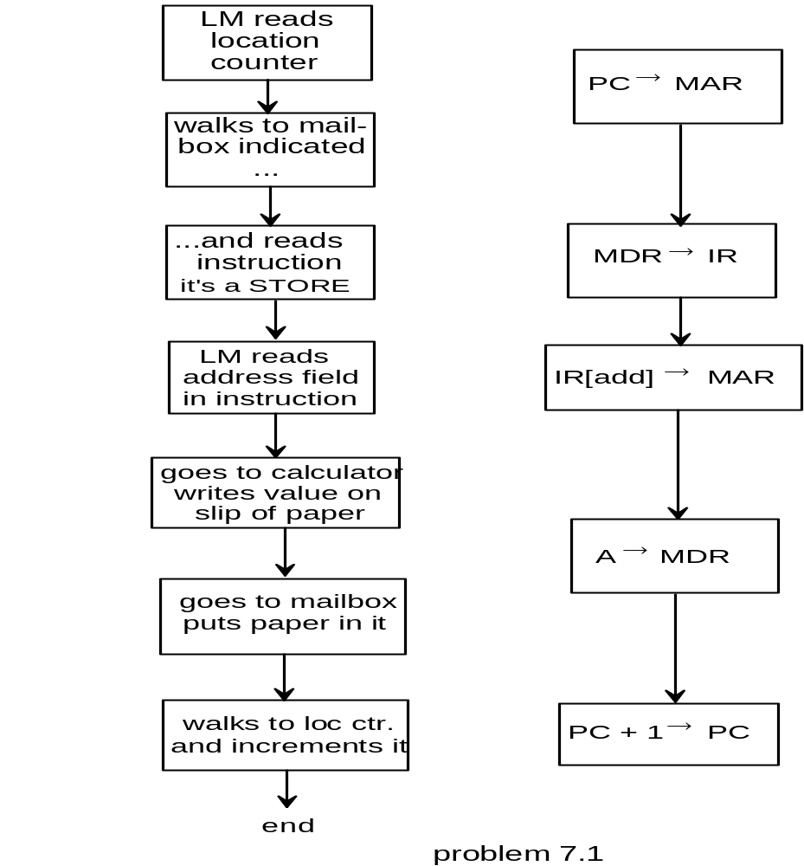

7.2 a. (BL2-) Working from the F/E cycle for instruction 20,

PC → MAR
MDR → IR ← final value of IR = 150
IR [address] → MAR ← final value of MAR = 50
MDR → A ← final valur of MDR and A = 724
PC + 1→ PC ← final value of PC = 21

b. (BL2-) PC MAR MDR IR A
PC → MAR 21 21 724 150 724
MDR → IR 21 21 351 351 724
IR [address] → MAR 21 51 351 351 724
A + MDR → A 21 51 006 351 730
PC + 1 → PC 21 51 006 351 730

7.3 (BL1+) A 36-bit MAR can support 2³⁶ = 2³⁰ × 2⁶ = 64 gigabytes of addressable memory.

7.4 (BL1+) There are two different registers associated with memory because each memory location has an address that identifies it and the data that is stored there, just as each mailbox in the LMC has both an address and the slip of paper containing the data stuffed into the slot.

7.5 (BL1-2) The LOAD, STORE, and ADD F-E cycles are given in the chapter. The remainder of the instructions are:

SUBTRACT IN OUT COFFEE BREAK
PC → MAR PC → MAR PC → MAR PC → MAR
MDR → IR MDR → IR MDR → IR MDR → IR
IR [add] → MAR IOR → A A → IOR
A - MDR → A PC + 1 → PC PC + 1 → PC
PC + 1 → PC

BRANCH ON CONDITION BRANCH
PC → MAR PC → MAR
If condition MDR → IR MDR → IR
not met → PC + 1 → PC IR [add] → PC
if condition met → IR[add} → PC

7.6 (BL2-) In the F/E cycle, the memory address to be accessed is always determined from the contents of another register, and is never changed independently. Therefore, it would never serve as the source of a register transfer. It is fair to note, however, that in some CPUs, instructions may require incrementing the MAR to retrieve successive memory locations for data or instructions that are split among multiple successive locations. Therefore, one might occasionally see

MAR + 1 → MAR

in the fetch-execute cycle for some CPUs.

7.7 (all BL2)
a. Shifting an unsigned number two bits to the left multiplies it by four, unless the value overflows. Overflow occurs if either of the two leftmost bits is a 1.

b. Any mix of 1's and 0's in the three leftmost bits will cause an overflow, and possibly a sign change as well. If all three leftmost bits are the same, the value is algebraically quadrupled.

c. The left shift still requires the leftmost bits to be the same, otherwise overflow occurs. However, at least the sign is now correct. Right shifts will divide the value in half for each bit shifted, provided that the sign bit is carried to the right each time. This assures a succession of 1's or 0's at the leftmost bit positions, and preserves the sign.

7.8 (BL2) If a computer is to be used in outer space, it would be advantageous to use nonvolatile memory to hold power and data during momentary power outages. This suggests the use of magnetic core memory, particularly if an alternative method of nonvolatile storage, such as disk, is not available. Even a momentary power glitch would affect RAM, making stable power backup a necessity.

7.9 (BL2)
COMPLEMENT
PC → MAR A different interpretation might treat -A → A
MDR→ IR as a one's complement operation, i.e it would
-A → A simply invert the 0's and 1's.
If so, a subsequent A + 1 → A would correct the result.
PC + 1→ PC

CLEAR
PC → MAR
MDR → IR
0 → A
PC + 1 → PC

(BL3+) This one's tough! It requires some real thought on the part of the student: To solve the problem, the students must realize that they have to load the opcode of the following instruction before they can determine how many steps to skip.

PC → MAR
MAR → IR
PC + 1 → PC
PC → MAR ;get opcode of next instruction
MAR → IR
If condition met → PC + IR[number] → PC

7.11 (BL3) Since it is only possible to access one memory location at a time, it will be necessary to access memory twice to fetch the entire instruction word. The instruction is in locations pointed to by PC and PC + 1. Therefore, the F-E cycle for an ADD instruction in this machine can be represented by

PC → MAR
MDR → IR [high]
PC + 1 → PC fetch
PC→ MAR
MDR → IR [low]
IR [low] → MAR
A + MDR→ A
PC + 1 → PC
Note that the PC is, indeed, incremented twice by this instruction.

7.12 (BL3) There are five basic steps to be performed:

a. fetch the instruction
b. retrieve the data from memory location XX
c. save the retrieved data in IAR
d. fetch the next location to get address YY
e. store the data from IAR to address YY

The following F-E cycle will do the job. The steps above are identified at the right:

PC → MAR
MDR → IR (step a)
IR [add] → MAR (step b)
MDR → IAR (step c)
PC + 1 → PC
PC → MAR
MDR → IR (step d)
IR [add] → MAR
IAR→ MDR (step e)
PC + 1 → PC

7.13 (BL3)
PC → MAR
MDR → IR
if A < 0 PC + IR [add] → PC
else PC +1 → PC

7.14 (BL2+) Larger computer words require more time to be moved from one part of the computer to another. When the word size grows beyond the need for more instructions and larger addresses, the extra time is wasted. More important, the sizes of integers used in calculations rarely exceed 16 bits, and almost never require more than 32 bits. Arithmetic operations on large data words require considerable extra time. Adds and subtracts must ripple carries and borrows through the word, and multiplies and divides require add and shift time for each bit in the word. If the data word is generally larger than the data being operated on, the extra time is wasted.

7.15 (BL2) Memory accesses are slow. They require a time delay after the MAR is loaded to decode, connect the MDR with the correct memory location, and allow the data to settle before data can be transferred. Register transfers are implemented directly within the CPU and are much faster.

7.16 (BL3) For the MOVE instruction,

PC → MAR
MDR → IR
GPR (IR[Addr1]) → GPR (IR[Addr2])
PC + 1 → PC

Comparing this F-E cycle with that of the LOAD instruction, it it is apparent that the MOVE instruction eliminates the second memory access required to obtain the data from memory with the LOAD instruction. Since memory accesses are the slowest operation, (See 7.15), the MOVE operation will be significantly faster than the LOAD.

7.17 (BL2+) For practical reasons, data processing in computers is generally done in parallel. Registers that hold data generally have one bit for each bit in a number or data word. Memory requires one bit for each bit in a data word. Calculations are generally done on all the bits in a number simultaneously, rather than one bit at a time. Thus, parallel data transfer on a bus is simplest, because data on serial buses usually has to be converted to parallel form for use in calculations. All of the bits of an instruction must be known before an instruction can be executed.

However, parallel buses suffer from inter-line interference and skew at high data rates. Additionally, the cost is high for substantial lengths of parallel buses, particularly when the number of lines is large. The amount of physical real estate when the parallel bus is part of a backplane is also large. These factors set the criteria for the tradeoffs between serial and parallel buses. For short bus runs and for slow speed bus data, the parallel bus is more efficient, and the difficulties and costs are minimal. When the system requires extremely high speed data transfer rates, long runs, and/or large numbers of bus lines, system designers will generally try to use serial buses instead.

7.18. (BL2+) Three shortcomings of parallel buses include noise interference between lines in a parallel bus, skewing at high data speeds, and cost. Noise interference and skewing can cause errors in the data being transferred, particularly when the bus length is longer than a few inches, and of course the cost becomes prohibitive for long cables. Skew is not an issue for serial cables, and the cost is more manageable. Although it is still possible for the cable to transmit and receive noise from the external environment, the interference between lines is minimized; Twisting data pairs and shielding the cable from the environment can reduce the noise even further. These solutions are not practical in a parallel cable.

7.19. (BL2) Skew is defined as the slight difference in arrival time among different data signals on a parallel bus. When the data speed is high, the amount of skew can exceed the sample time of the data, causing data errors. Since the data on a serial bus is transferred sequentially on a single line, there is no skew. (Although it would be possible to sample the data at the wrong instants due to poor clock synchronization, there are methods for using the data signal itself as a synchronizing clock to assure that this does not happen. These methods are discussed in Chapter 14.)

7.20. (BL2+) Point-to-point buses generally do not require addressing lines because the single point to which the data is to be delivered is the only point directly connected to the bus other than that of the sender, and is thus known to both the sender and the receiver. If the receiving end of the bus represents multiple addresses, then the address for a particular data word or group of data must, of course, be identified. This can be achieved by multiplexing the address with the data using the same data lines, address first, then data. Multiplexing is even used on some general-purpose buses as a means of reducing the overall number of lines on a parallel bus and is also used as a means of providing addresses on a serial bus.

